Numerical Analysis

Homework 4 Report

Leung Ko Tsun (梁高浚)

T10902303

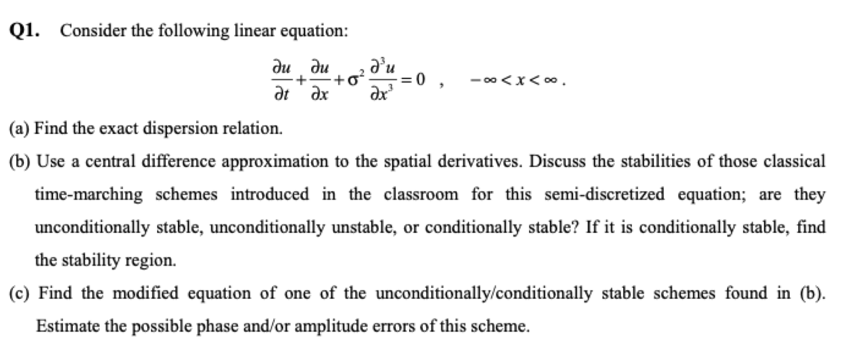

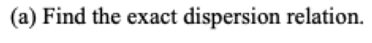

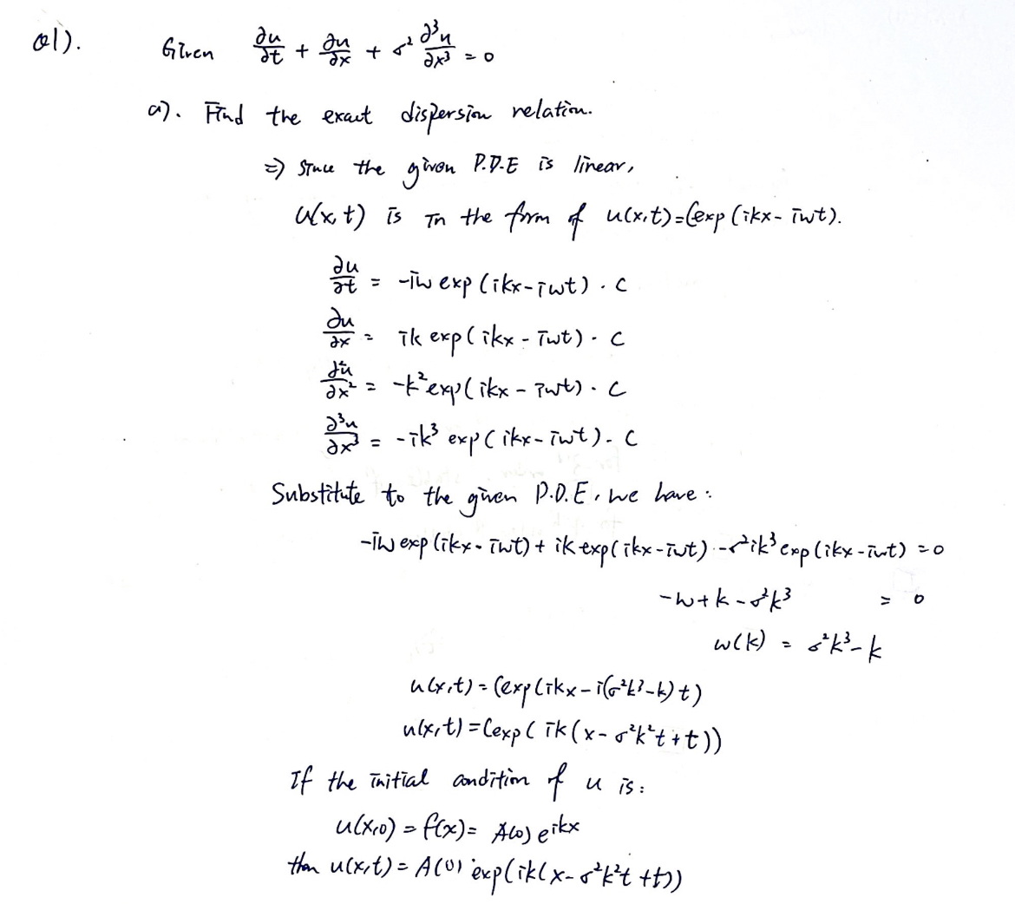

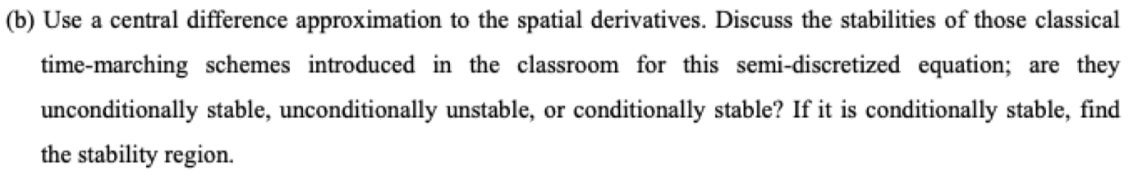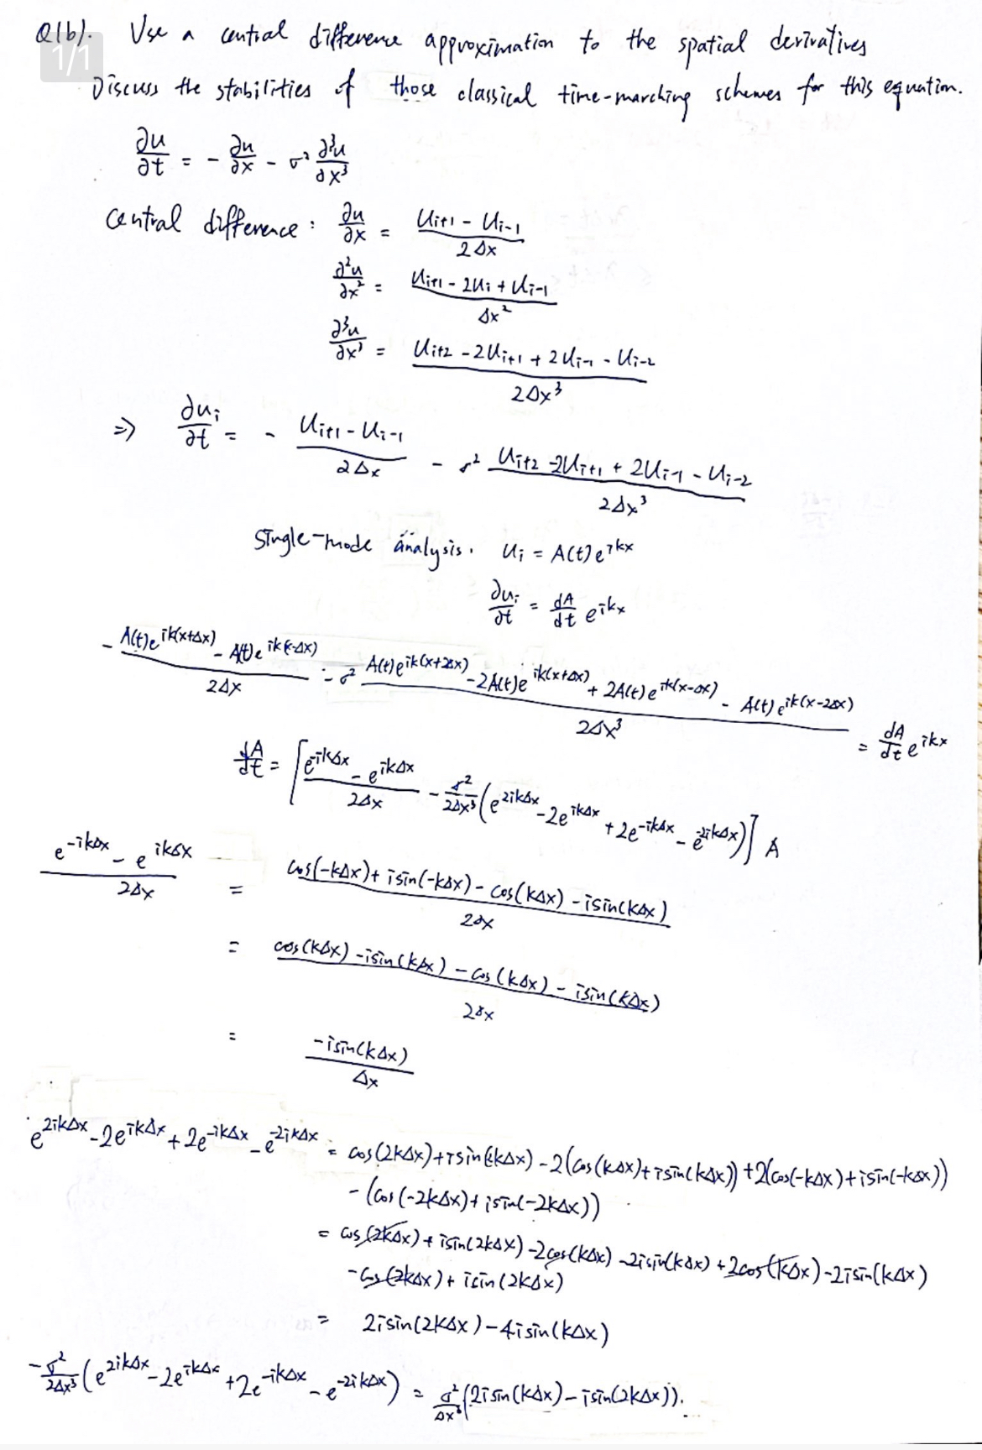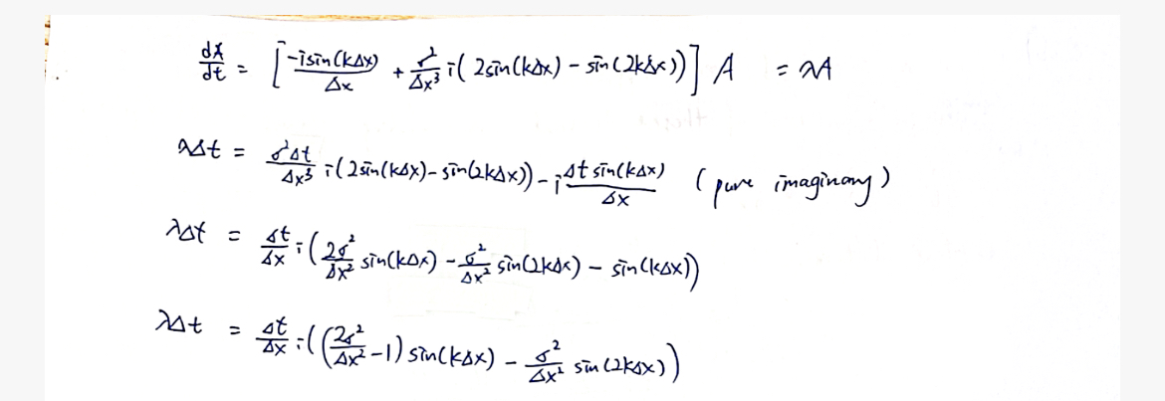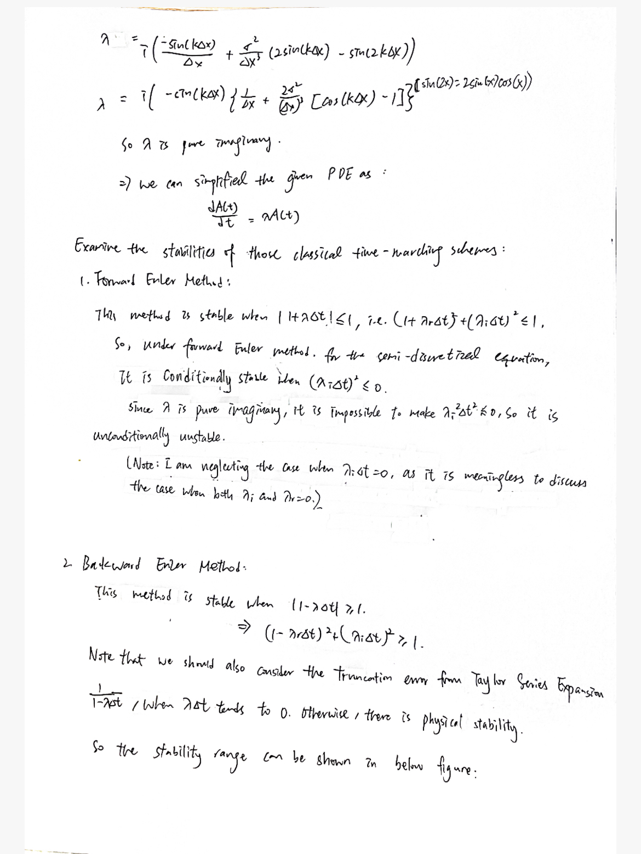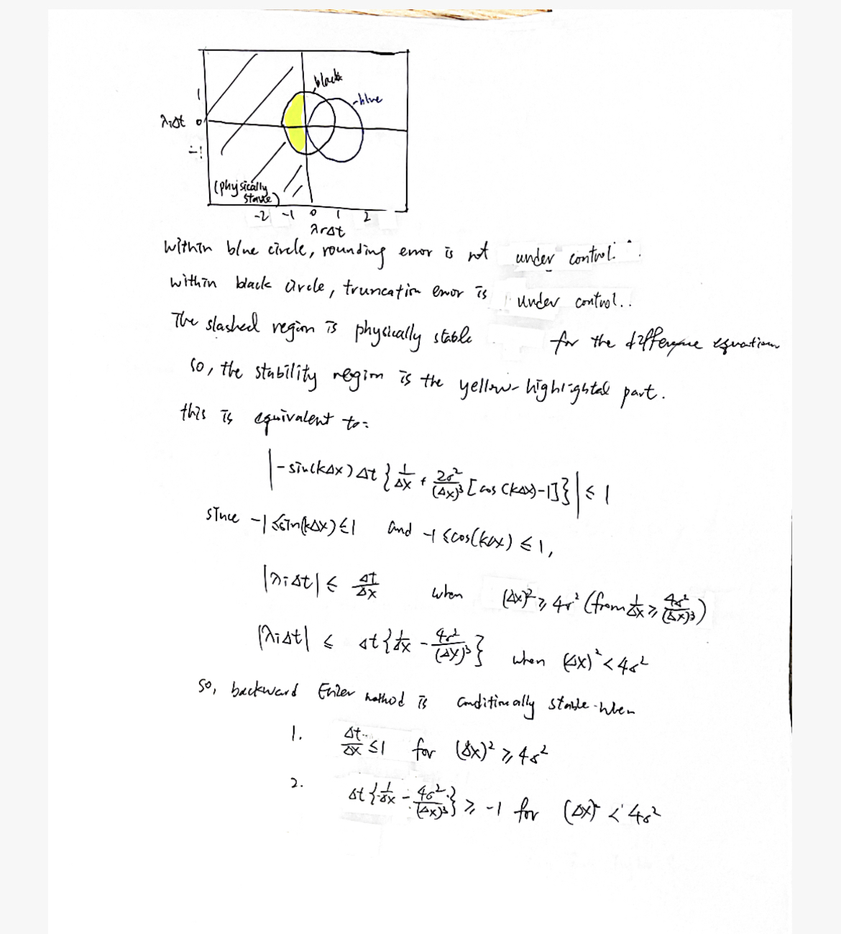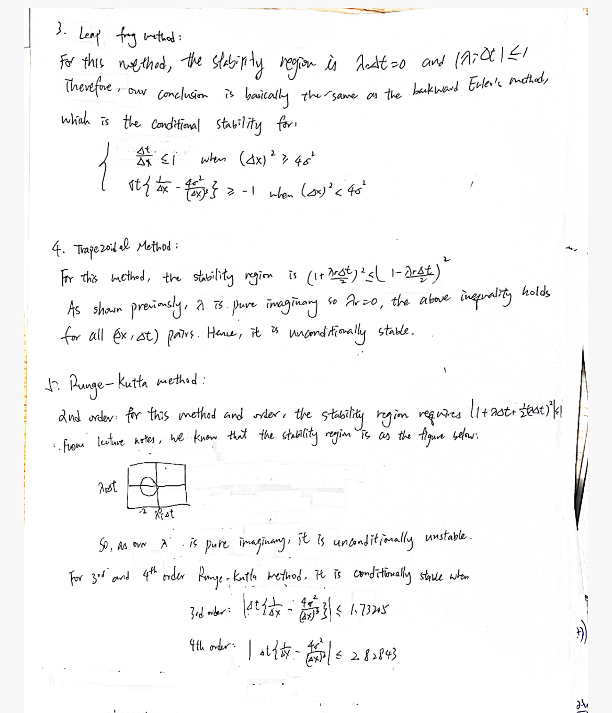

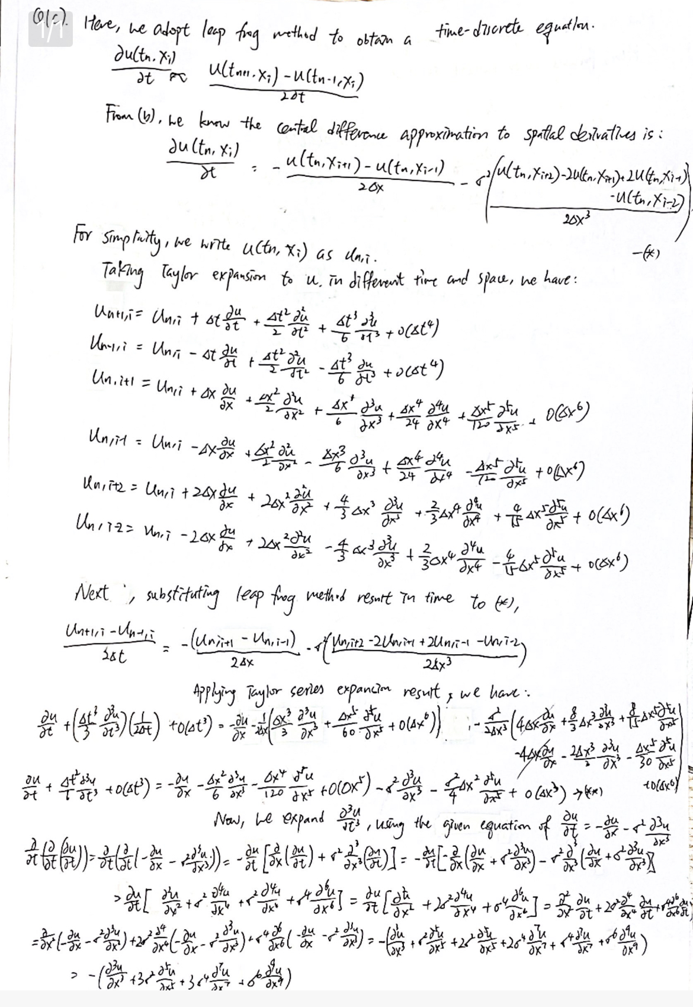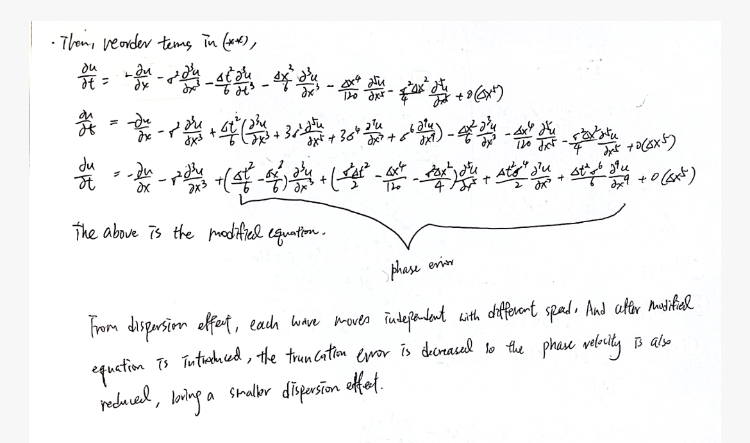

For the amplification error, denote the amplication factor of the exact solution as e^{omega_i*delta_t}, and the amplitification factor from numerical solution is |p|, then the diffusion error can be calculated by |p|/^{omega_i*delta_t}, and if this value equals to 1, then there is no diffusion error.

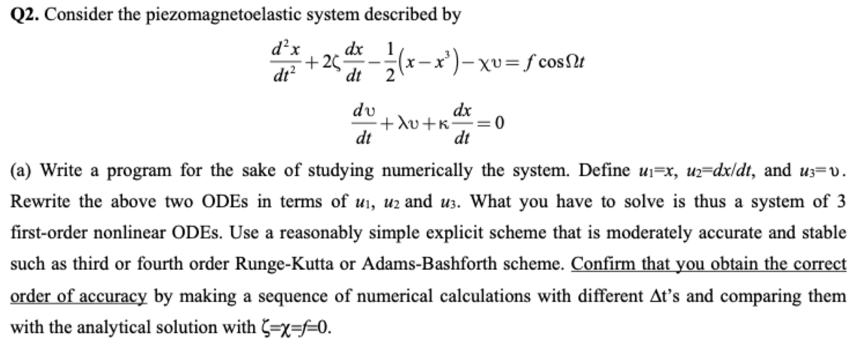

a).

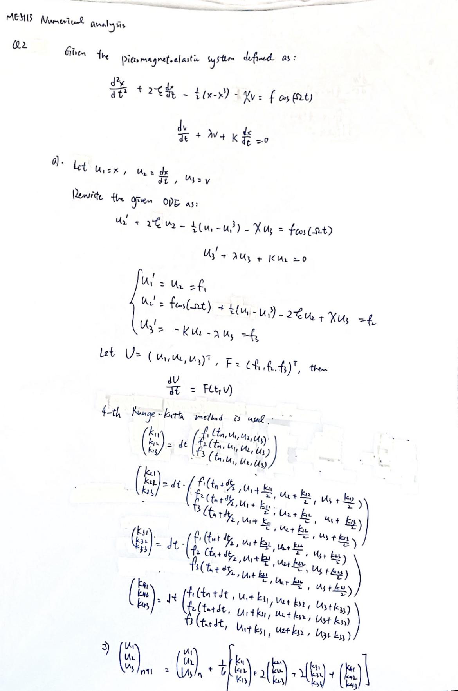

The above 4-th order Runge Kutta method is programmed in Python. The graph of ln|error| vs ln|dt| is examined, with error defined as absolute difference between h(u1,u2) at t = 0 and h(u1,u2) at t = 10.

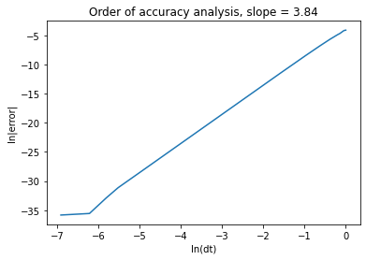

Also, the 3-th order Runge Kutta method is implemented as well, to validate the order of accuracy. The slope is 2.9999919508098523, which is very close to 3, so we can confirm our Runge Kutta method is correct.

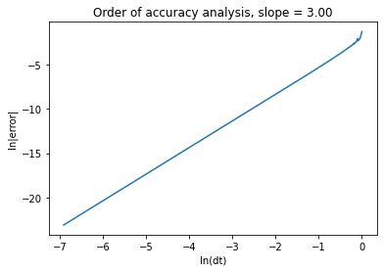



B). Under the case of chi = f = 0, and the following phase portraits are obtained(with u1 as the horizontal axis and u2 as the vertical axis) by putting many trajectories together.

(Note: parameter “xi” is referring to zeta in the following graphs)

When chi = f = 0 and zeta = 0 (same as the setting of previous homeworks), the portrait map is

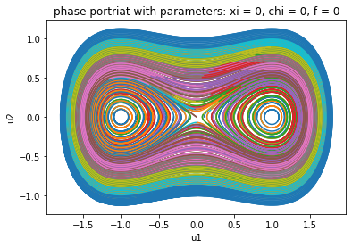

When xi = 0.32, chi = f = 0, we have the following portrait map:

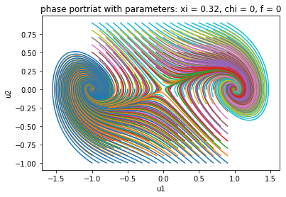

When xi = 0.64, chi = f = 0, we have the following portrait map:

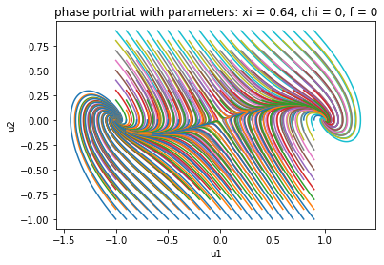

Analysis: for the case when chi = 0, f = 0 and zeta = 0, we have three fixed points, which are (-1,0), (0,0) and (1,0). This result matches the conclusion from previous homeworks. With zeta starting to increase, we can observe that (-1,0),(1,0) are still converging points, but the points around (0,0) starts to diverge. With a larger zeta, the rate of convergent/divergent is faster.

Q2c). 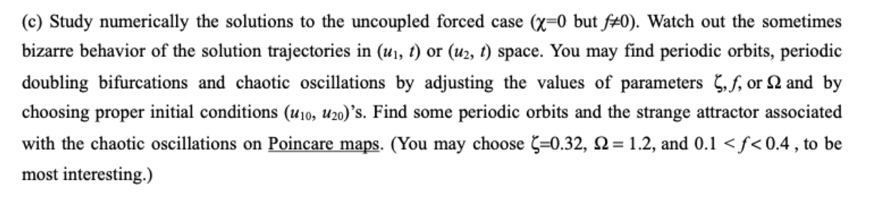

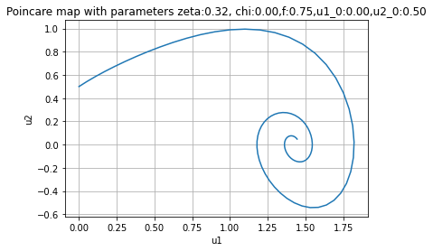

For the uncoupled forced case, i.e. chi = 0 but f =/= 0, we can see there is a convergent point of (u1=1.4,u2=0.1). The above graph is generated under the following setting:

T = 10

zeta = 0.32

Chi = 0

f = 0.75

u1 initial value = 0

u2 initial value = 0.5

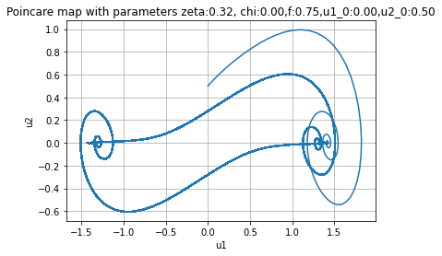

Then, I try to add T to a very large number, and collect samples in every 2*pi/omega interval. Detailed setting is listed below:

omega = 1.2

T = 100000 * 2*pi/omega

zeta = 0.32

Chi = 0

f = 0.75

u1 initial value = 0

u2 initial value = 0.5

Interesting result is shown on the above figure, there are three convergent point, which are (u1=-1.4, u2=0), (u1=1.2, u2=0), and (u1=1.3, u2=0).For the first two converging points, they shows a double periodic orbit pattern. The third converging point is from the data points under small T situation. When T starts to increase to a large number, the behavior of the solution starts to change. It is no longer convergent to only that point, but showing a periodic doubling bifurcation behavior.

The graph of three solutions versus time is also plotted:

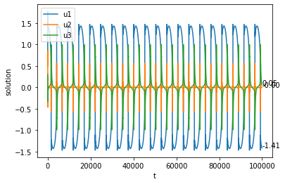

which confirms our believe that the Poincare map should show a periodic doubling bifurcation behavior.

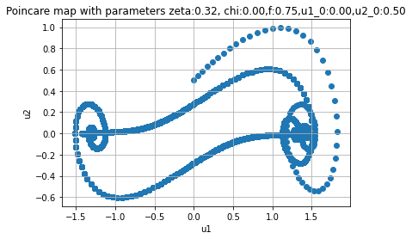

Turning the above graph in scatter plot, we can visualize the data point distribution, and we can confirm our conclusion above: after first few iterations, most of the other points are concentrated to the double periodic orbit pattern.

Then, I tried different values to examine if there is any other interesting behaviour.

I set zeta to be 1.5, other keeping the same, and T = 10 gives us this graph:

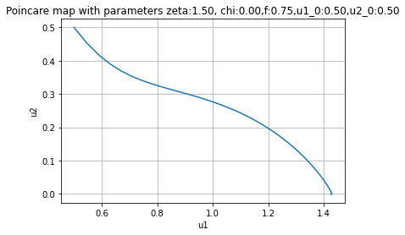

From this graph, we cannot see any convergent behaviour, so we may deduce that the value of zeta affects the convergent radius. 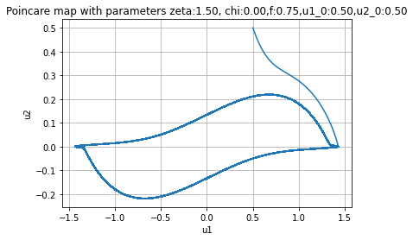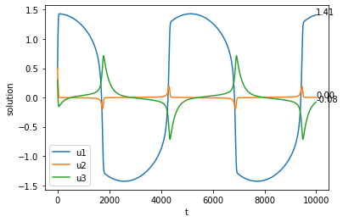

I extended the time domain to 10000, then we have interesting result. The graph shows a double periodic orbit behavior, similar to the above setting, but with less circle and faster convergence. So we may deduce that the value of zeta affects the convergent rate as well.

For the solutions versus t graph, u1,u2,u3 all shows a periodic movement, where u1 has a specific pattern like a “D”, the value change significantly in some t, not showing a convergent behavior. For u2, it also moves in a specific pattern, and not showing a convergent behavior. So it explains the reason why the value may move from (1.4,0) to (-1.5,0) along the orbit from the above poincare map.

I have also found an interesting result from setting small zeta and small f.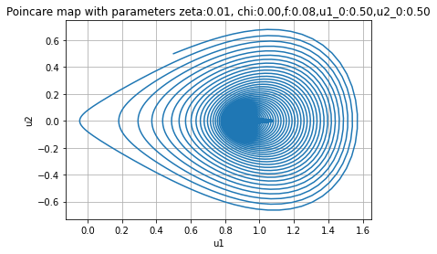

It shows a different convergent behavior compared to the above analysis. For small zeta and small f, when time elapses, the value of u1 and u2 is bounded within a circular-like region, and the radius of the circle get smaller and smaller, finally converges.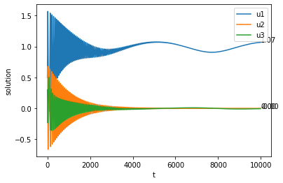

The convergent behavior of u1,u2,u3 is shown above, which we can observe that the movement of u1 does oscillate like a sine wave after t = 4000, but still bounded within a range, finally converges to 1.07.

d). Study numerically the piezomegnetoelastic system(chi =/= 0) without external forcing(f=0).

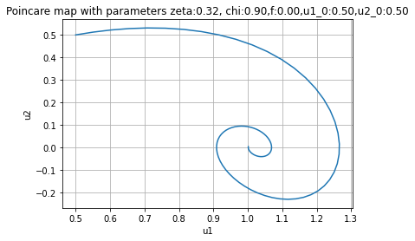

When chi =/= 0 but f = 0, we can see there is a convergent point of (u1=1,u2=0). The above graph is generated under the following setting:

T = 10

zeta = 0.32

Chi = 0.9

f = 0

u1 initial value = 0.5

u2 initial value = 0.5

Then, extending the time domain to 10000, we have:

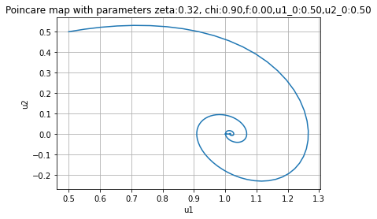

It still shows a convergent pattern, with more points concentrated on the convergent point, without showing the double periodic bifurcation behavior as (c). So, we may deduce that the value of f determines the convergence and periodic behavior of the solutions.

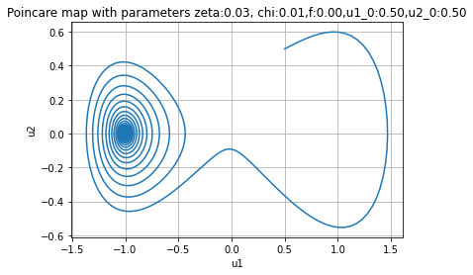

Then, I tried to make chi and zeta to be small, examine if zeta is sensitive to chi. It shows an interesting result that the value starts from (0.5,0.5) and converges to (-1,0). It means that in this situation, u1,u2 are actually having a real solution, and it is independent from the initial condition.

I tried to change the initial condition to (1.0, 1.5), and found that the convergent path moves in a circle, overlapping the above (0.5,0.5) convergent path. So we can deduce that the convergent path is also deterministic, and it moves like a oval shape.

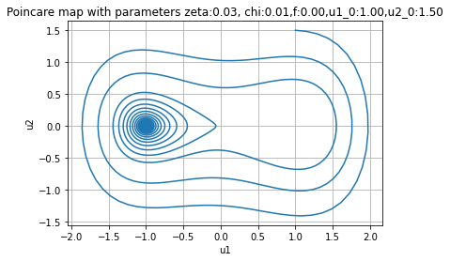

We can observe that most of the points concentrate to (u1=-1.0, u2=0.0) after several iterations.

I have tested multiple values, and most of the cases can be classified in the above discussion, so they are not posted here, but generally, I did not find any double periodic pattern nor chaotic pattern.

e). Study numerically the piezomagnetoelastic system(Chi =/= 0) with external forcing(f=/=0)

When Chi =/= 0 and external forcing is applied, the phase space also shows interesting result.

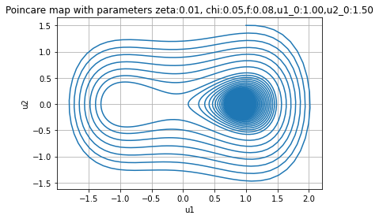

Under the suggested setting in the lecture notes, this Poincare map shows a different convergent point compared to the one in (d). It converges to (1.0,0) and the convergent path is also deterministic, that is, it will overlap the convergent path of those u1,u2 smaller than the u1,u2 initial values.

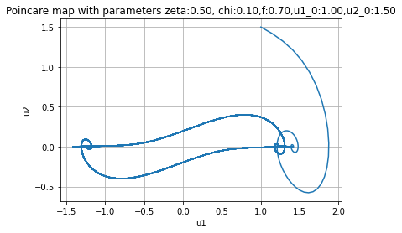

When zeta, chi and f are set to be larger, the behavior shown is similar to the one in (c), showing a double periodic pattern.

Then I set zeta to be small, but still keeping chi and f to be large, interesting result is shown here where we have two convergent point, which are (-1.4,0) and (1.3,0) respectively. But in this case, the solutions are actually not converging, as they move around in this two convergent circles.

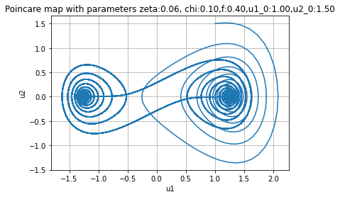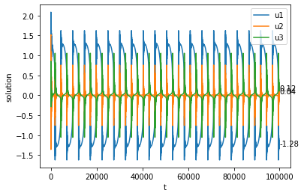

We can confirm this conclusion by the above graph, u1,u2,u3 are still oscillating after a long period of time and does not show a convergent pattern.

I have also tested other values, but they can be mostly classified to the case discussed above, so they are not listed here.